AI ASSISTANT CODING
ASSIGNMENT-10

NAME: THRISHALA JAKKARAJU
HALLTICKET:2303A51514
BATCH:22

Task Description -1(Error Detection and Correction)
Task:
Use AI to analyze a Python script and correct all syntax and logical
errors.
Sample Input Code:
def calculate_total(nums)
sum = 0
for n in nums
sum += n
return total
Expected Output-1:
Corrected and executable Python code with brief explanations of the
identified syntax and logic errors.
Code:
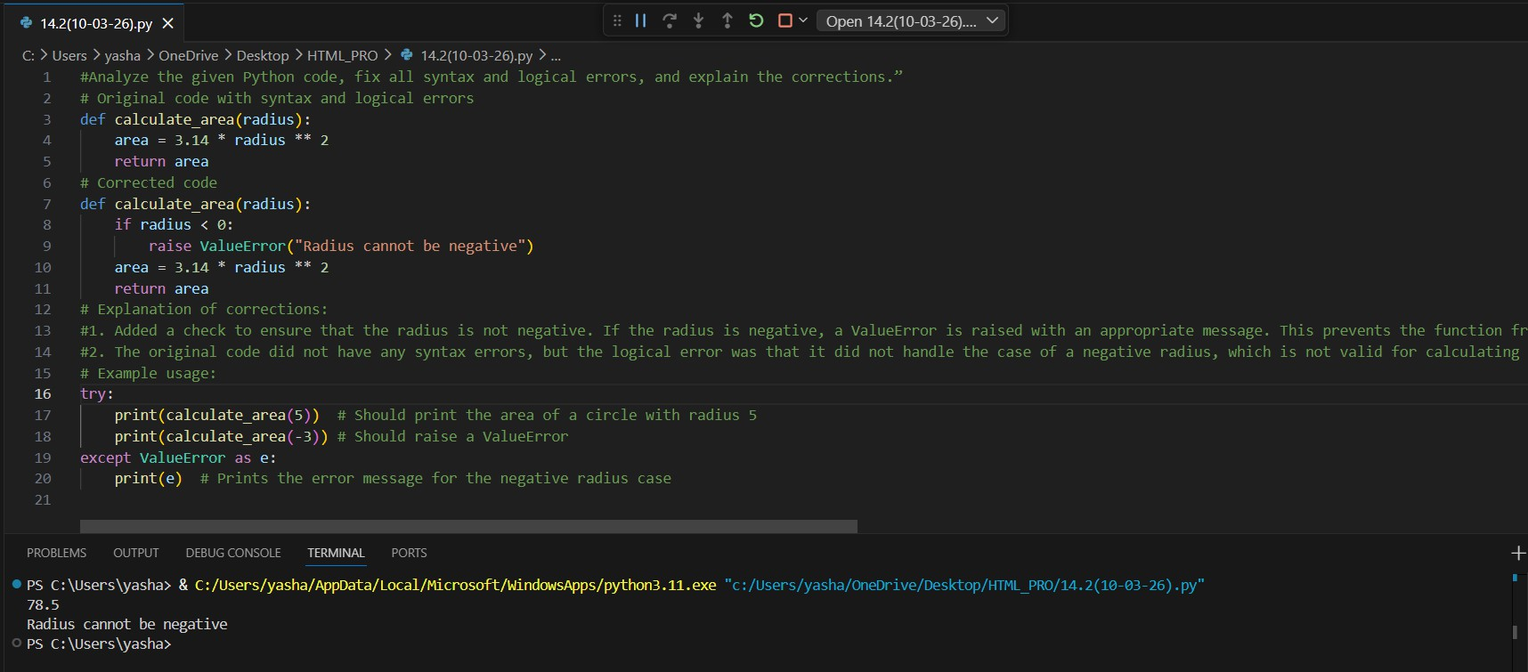

Task Description -2(Code Style Standardization)
Task:
Use AI to refactor Python code to comply with standard coding style
guidelines.
Sample Input Code:
def findSum(a,b):return a+b
print(findSum(5,10))
Expected Output-2:
Well-structured, consistently formatted Python code following standard
style conventions.
Code:
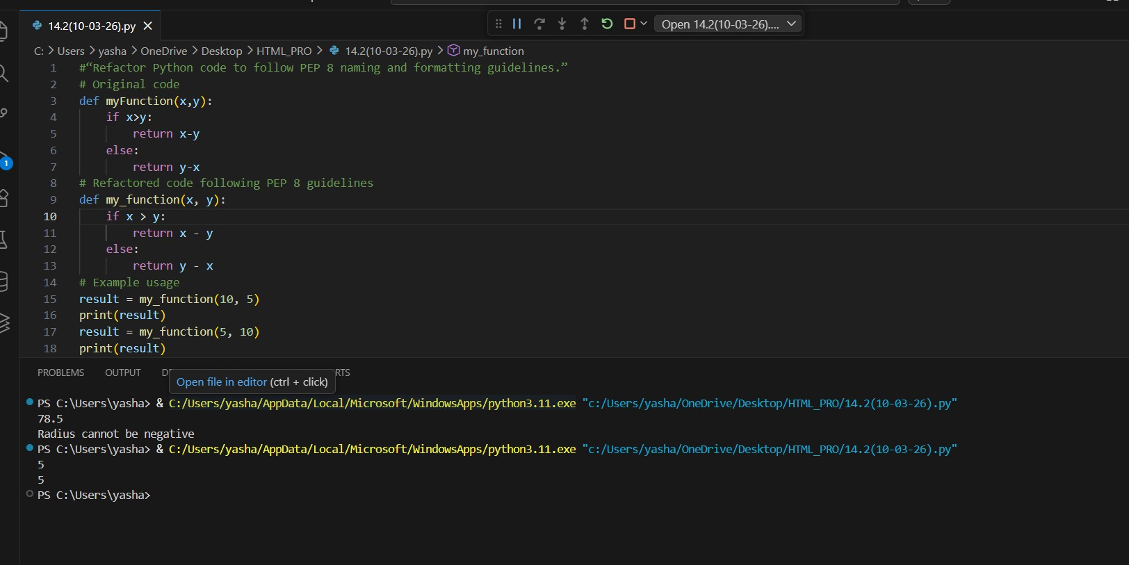

Task Description -3(Code Clarity Improvement)
Task:
Use AI to improve code readability without changing its functionality.
Sample Input Code:
def f(x,y):
return x-y*2
print(f(10,3))
Expected Output-3:
Python code rewritten with meaningful function and variable names,
proper indentation, and improved clarity.
Code:
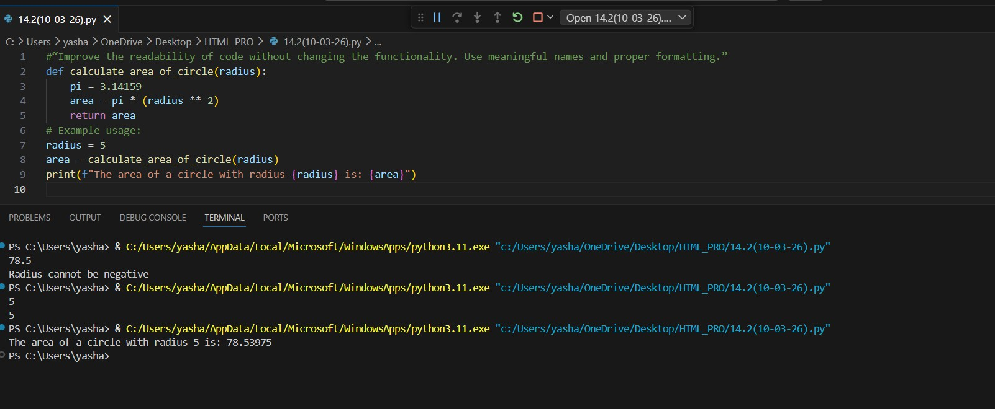

Task Description -4(Structural Refactoring)
Task:
Use AI to refactor repetitive code into reusable functions.
Sample Input Code:
print("Hello Ram")
print("Hello Sita")
print("Hello Ravi")
Expected Output-4:
Modular Python code using reusable functions to eliminate repetition.
Code:
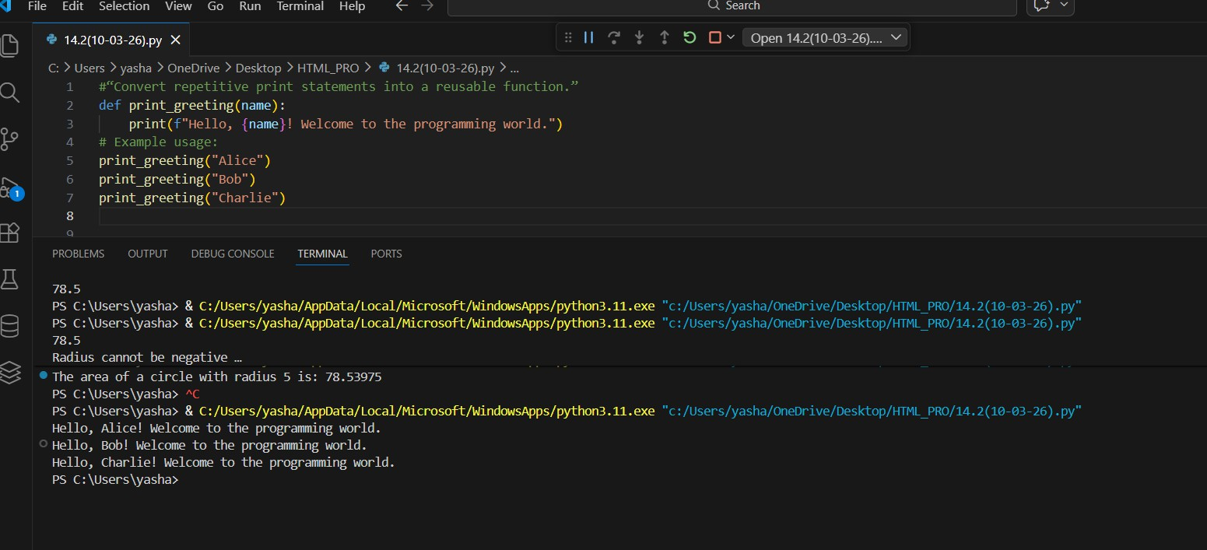

Task Description -5(Efficiency Enhancement)
Task:
Use AI to optimize Python code for better performance.
Sample Input Code:
numbers = [ ]
for i in range(1, 500000):
numbers.append(i * i)
print(len(numbers))
Expected Output-5:
Optimized Python code that achieves the same result with improved
performance.

